Part I: Research Question

Note: Your responses to the following task prompts must be provided in a document file. Unless otherwise specified, responses to PA requirements that are included in a Python or RStudio notebook will not be accepted.

A. Describe the purpose of your report by doing the following:
1. Propose one question relevant to a real-world organizational situation that you will answer using market basket analysis.
What product combinations are frequently purchased together in the megastore, and how can this information be used to optimize product placement and marketing strategies?
2. Define one goal of the data analysis. Ensure your goal is reasonable within the scope of the provided scenario and is represented in the available data.
The goal of the analysis is to identify frequent product combinations using market basket analysis. This will help the organization optimize product placement, design promotional bundles, and improve cross-dual-selling opportunities.

Part II: Market Basket Justification

Note: Your responses to the following task prompts must be provided in a document file. Unless otherwise specified, responses to PA requirements that are included in a Python or RStudio notebook will not be accepted.

B. Explain the reasons for using market basket analysis by doing the following:
1. Explain how the market basket technique analyzes the provided dataset, including expected outcomes.
Market basket analysis uses association rule mining to identify relationships between items frequently purchased together in transactions. The Apriori algorithm is commonly used to generate association rules based on metrics like support, confidence, and lift. The expected outcomes should be that Insights into product combinations that can inform marketing strategies, such as bundling or cross-selling.
2. Provide one example of a transaction in the dataset.
3. Summarize one assumption of market basket analysis.
Market basket analysis assumes that the presence of one item in a transaction can influence the likelihood of another item being purchased. This also leads to independence between transactions but dependence between items within a transaction.

Part III: Data Preparation and Analysis

Note: Your responses to the following task prompts must be provided in a document file. Unless otherwise specified, responses to PA requirements that are included in a Python or RStudio notebook will not be accepted.

C. Prepare the dataset for further analysis by doing the following:
1. Wrangle (i.e., transform) data by doing the following:
- a. Select x number of categorical variables, choosing at least two ordinal variables and at least two nominal variables.
- Ordinal Variables:
  - Order Priority
  - Customer Satisfaction
- Nominal Variables:
  - Product Name
  - Payment Method

b. Perform the appropriate encoding method (ordinal, label encoding, one-hot encoding) for each variable selected in part C1a. (Its in the annotated code)
c. Transactionalize the data for market basket analysis. (Its in the annotated code)
d. Explain and justify each step you took in parts C1a, C1b, and C1c. For C1a I selected two ordinal and two nominal variables, in B, I picked the one-hot and ordinal coding because of the variables, for 1c, I transactionally the data by turning the items columns into a transaction list and then applying the association rules so it will tell us the most frequent combo of items purchased.
2. Include a copy of the cleaned dataset.
3. Execute the code used to generate association rules with the Apriori algorithm. Provide a screenshot that demonstrates that the code is error-free.
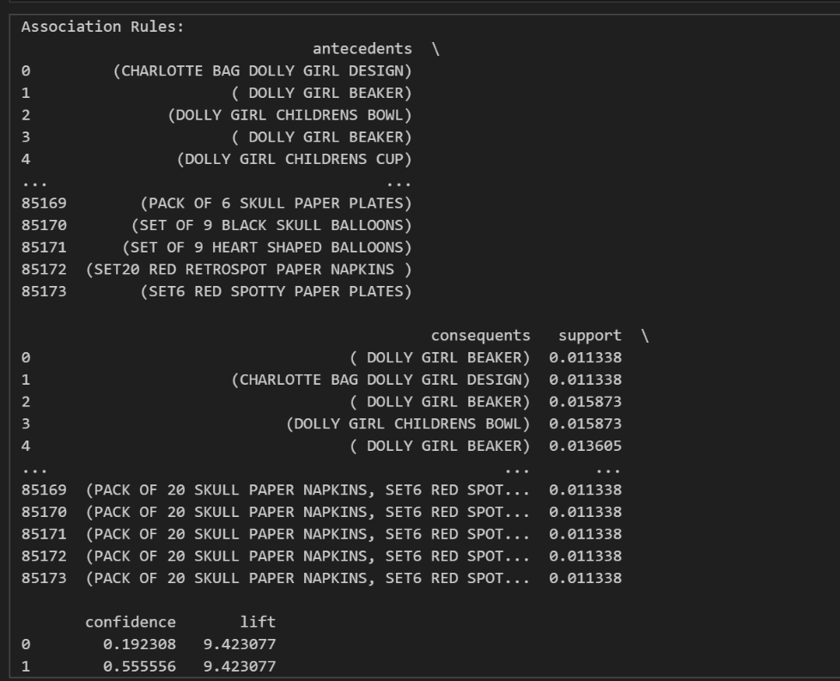
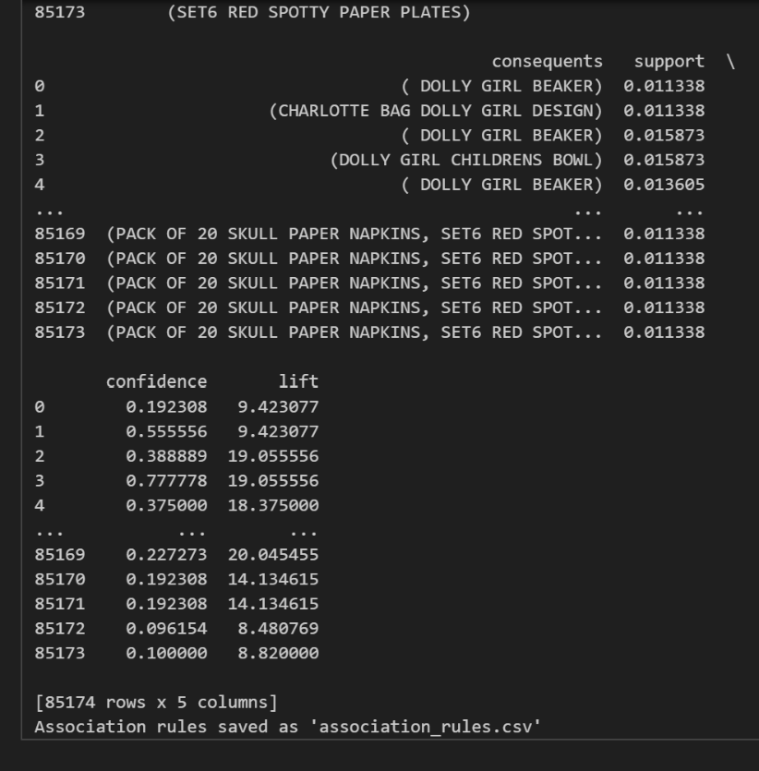
4. Provide values for the support, lift, and confidence of the association rules table. Include a screenshot of the values.
5. Explain the top three relevant rules generated by the Apriori algorithm. Include a screenshot of the top three relevant rules.
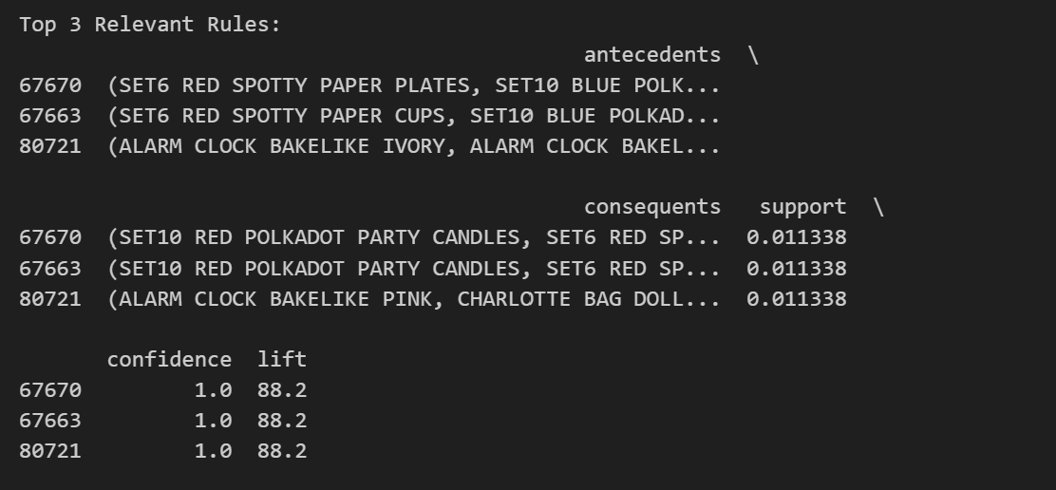
Part IV: Data Summary and Implications

Note: Your responses to the following task prompts must be provided in a document file. Unless otherwise specified, responses to PA requirements that are included in a Python or RStudio notebook will not be accepted.

D. Summarize your data analysis by doing the following:
1. Discuss the significance of support, lift, and confidence from the results of the analysis.
Support:
Value: 0.011338 (approximately 1.13% of transactions).
Significance: This means that the itemsets in the rules appear in about 1.13% of all transactions. While this is a relatively low percentage, it is still significant enough to identify patterns in customer behavior.
Confidence:
Value: 1.0 (100%).
Significance: This indicates that whenever the antecedents are purchased, the consequents are always purchased as well. This is a very strong association and a deterministic relationship between the items.
Lift:
Value: 88.2.
Significance: A lift value of 88.2 means that the antecedents and consequents are 88.2 times more likely to be purchased together than if they were independent. This is an extremely strong association and highlights the importance of these itemsets.
2. Explain the practical significance of your findings from the analysis.
Rule 1:
Antecedents: (SET6 RED SPOTTY PAPER PLATES, SET10 BLUE POLKADOT PARTY CANDLES)
Consequents: (SET10 RED POLKADOT PARTY CANDLES, SET6 RED SPOTTY PAPER CUPS)
Practical Significance: Customers who purchase red and blue polka-dot party supplies are highly likely to purchase matching red polka-dot candles and cups. This suggests a strong preference for themed party supplies.
Rule 2:
Antecedents: (SET6 RED SPOTTY PAPER CUPS, SET10 BLUE POLKADOT PARTY CANDLES)
Consequents: (SET10 RED POLKADOT PARTY CANDLES, SET6 RED SPOTTY PAPER PLATES)
Practical Significance: Similar to Rule 1, this rule highlights the tendency of customers to purchase complementary party supplies in matching themes.
Rule 3:
Antecedents: (ALARM CLOCK BAKELIKE IVORY, ALARM CLOCK BAKELIKE GREEN)
Consequents: (ALARM CLOCK BAKELIKE PINK, CHARLOTTE BAG DOLL DESIGN)
Practical Significance: Customers who purchase vintage-style alarm clocks in ivory and green are highly likely to purchase the pink version and a doll-themed bag. This suggests a niche market for vintage-style products and related accessories.

3. Recommend a course of action for the real-world organizational situation from part A1 that is based on the results from part D1. Bundle the items in the top rules together and offer discounts to encourage customers to purchase the entire set.

